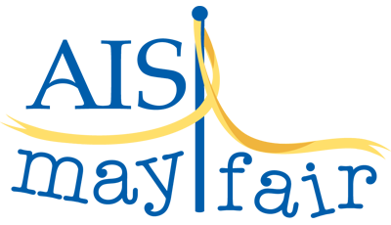

Raffle and Chance Items Needed for Mayfair Raffle Booth!
Dear parents,
We have pulled together a fun “wish list” of larger items for the popular Mayfair raffle booth. This booth is one of the largest money makers at Mayfair. We are looking for help in underwriting some of these items. We also hope to have at least 20 chance items. Thank you to the generosity of many parents who have already come forward with donations. No time to shop? No problem, we can put a monetary donation towards any item. Everything is appreciated. Thank you!
Colleen Blejwas cdblejwas@verizon.net and Kitty McQuaid kittymcquaid@verizon.net
Already Underwritten Raffle Items:
- Year End Pizza Party for Entire Grade
- Snow Cone Maker and Cotton Candy Machine Pack
- Isabelle American Girl Doll
Raffle Opportunities:
- Art Easel and Supplies
- Sewing Machine
- Apple I Touch
- Additional large raffle items are currently being identified. Contact us for underwriting opportunities.
Chance Opportunities:
Family Game Tower, Craft Kits, Chocolate Fountain, Book Tower, Legos, etc.

